**CHEMICAL INFORMATION MANAGEMENT SYSTEM C.I.M.S**



**DEPARTMENT OF OCCUPATIONAL SAFETY AND HEALTH (DOSH) JUNE 2011**

**User Manual f or Supplier Module (Registration)**

Chemical Information Management System

Department of Occupational Safety and Health Malaysia

**CONTENTS**

**USER MANUAL FOR SUPPLIER MODULE (REGISTRATION) ........................................................................ 2**

CHEMICAL INFORMATION MANAGEMENT SYSTEM ............................................................................................ 2

**MAIN SCREEN .......................................................................................................................................... 3**

**REGISTRATION ......................................................................................................................................... 4**

**LOGIN ...................................................................................................................................................... 6**

**Main screen**

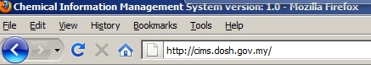

Web address: <http://cims.dosh.gov.my>

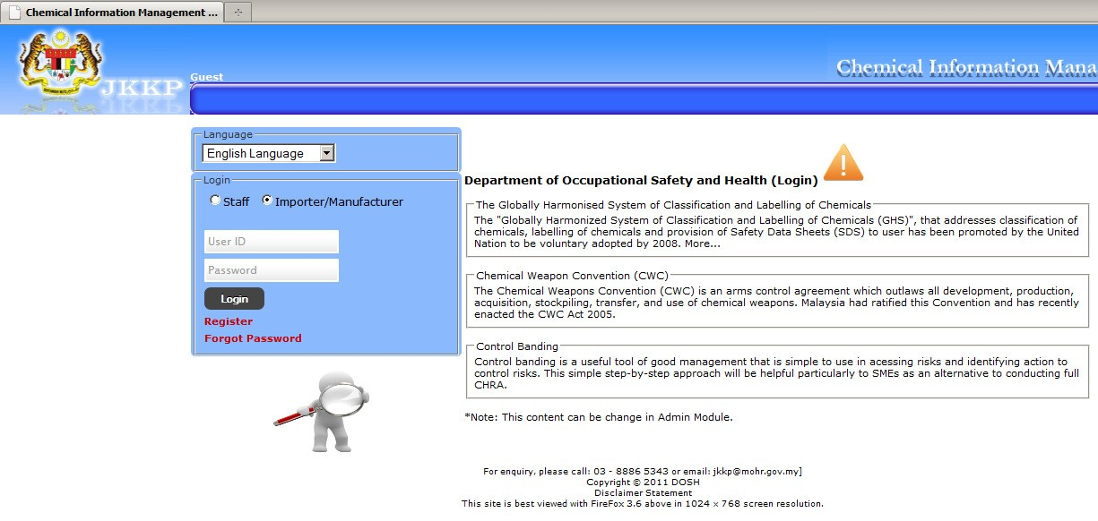

Home screen

**Registration**

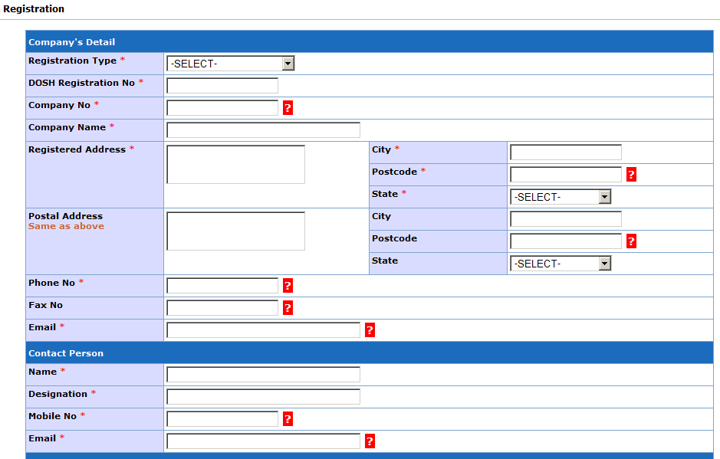

Registration form

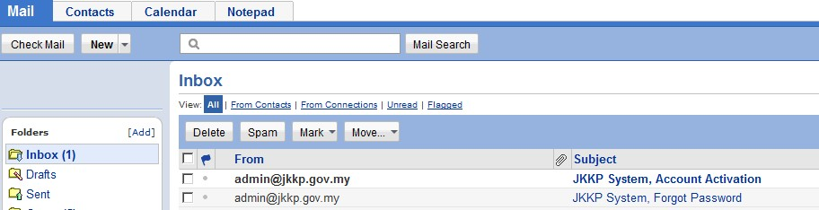

Receive notification at email.

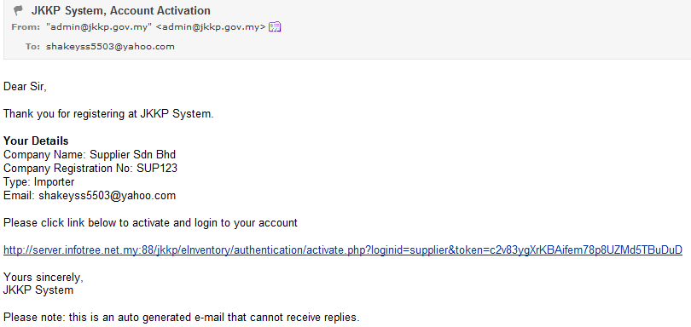

Click activation link.

Activation success

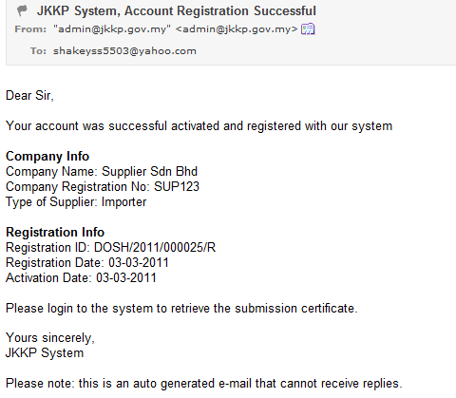

Receive email notification of successful registration.

**Login**

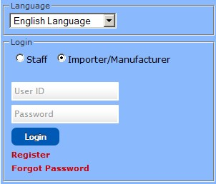

Login CIMS as Importer/Manufacturer (Supplier)

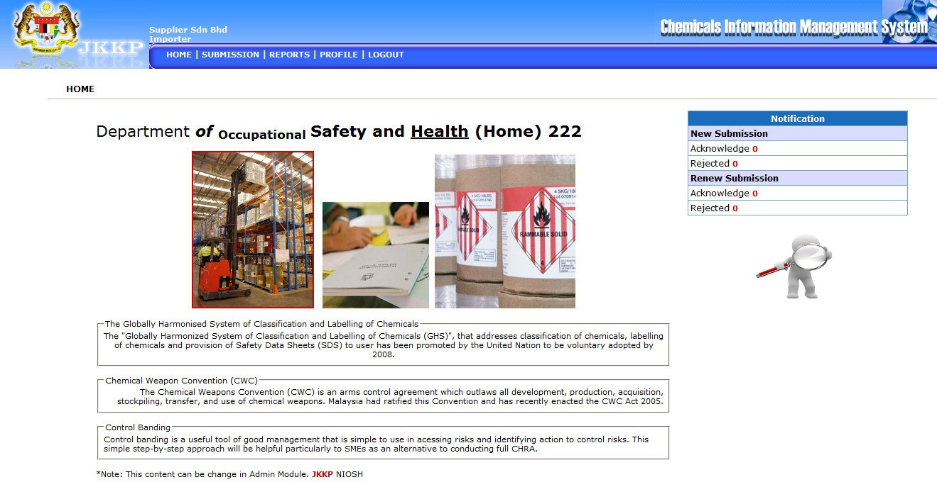

Home screen for supplier.